**The Long Answer: there are 3 different branches to delete!**

When you're dealing with deleting branches both locally and remotely, keep in mind that **there are 3 different branches involved**:

1. The local branch X.
2. The remote origin branch X.
3. The local remote-tracking branch origin/X that tracks the remote branch X.

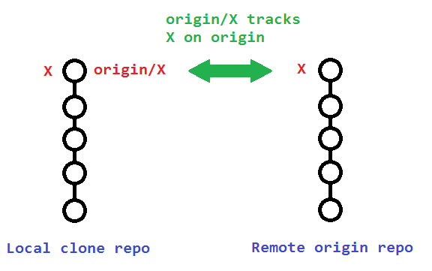

The original poster used

git branch -rd origin/bugfix

which only deleted his **local remote-tracking branch** origin/bugfix, and not the actual remote branch bugfix on origin.

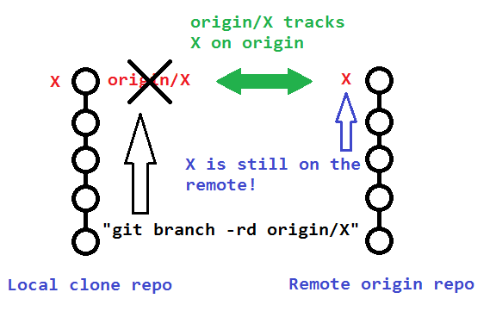

**To delete that actual remote branch**, you need

git push origin --delete bugfix

